**Identity and Access Management**

**EX-NO:03 DATE:19-02-2025** **AIM:**

Learn about identification, authentication, authorisation, accounting, and identity management.

**PROCEDURE:**

* Task 1 Introduction
* Task 2 IAAA Model
* Task 3 Identification
* Task 4 Authentication
* Task 5 Authorisation and Access Control
* Task 6 Accountability and Logging
* Task 7 Identity Management
* Task 8 Attacks Against Authentication
* Task 9 Access Control Models
* Task 10 Single Sign-On
* Task 11 Scenarios
* Task 12 Conclusion **Task 1:**

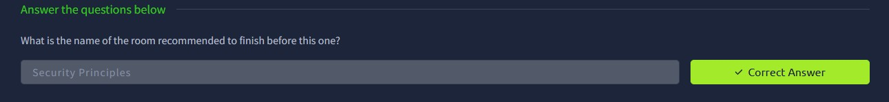

**Task 2:**

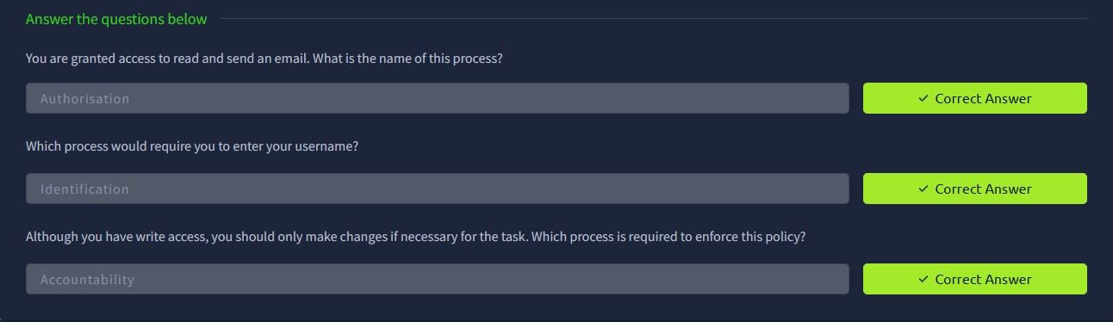

**Task 3:**

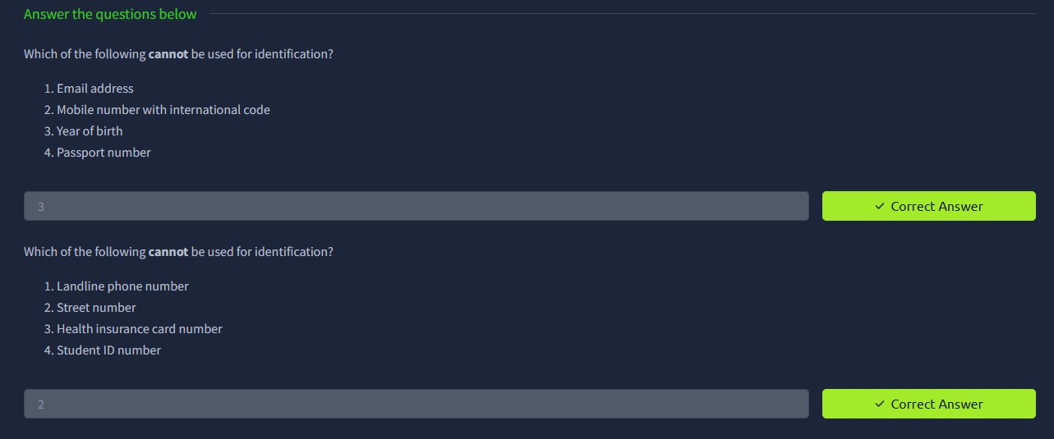

**Task 4:**

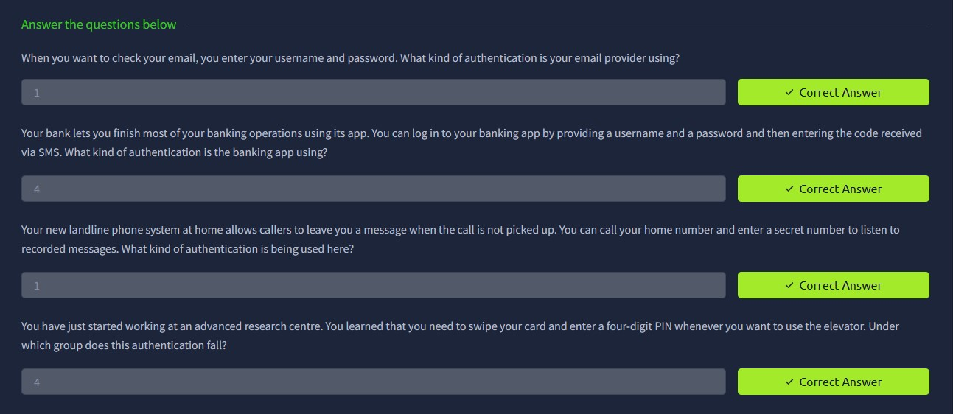

**Task 5:**

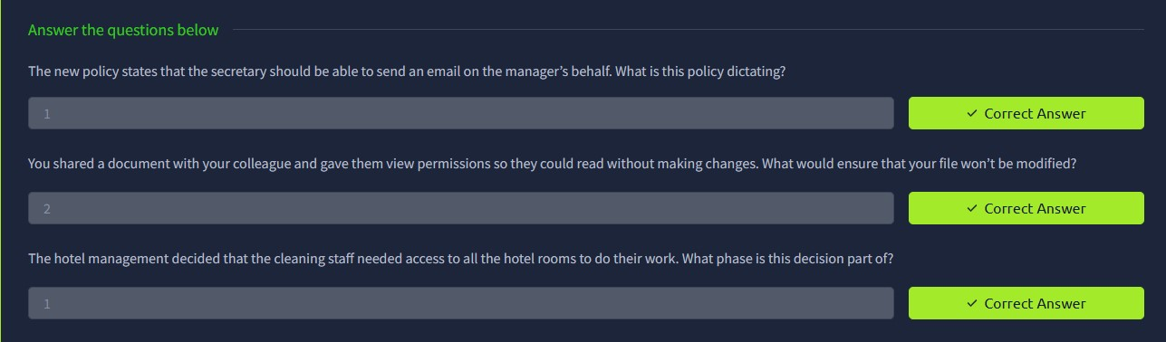

**Task 6:**

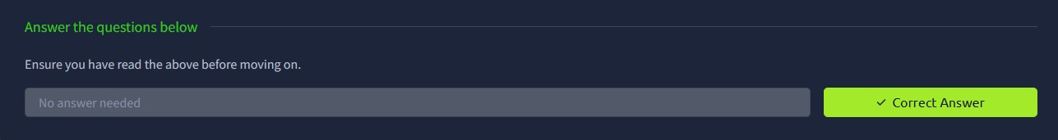

**Task 7:**

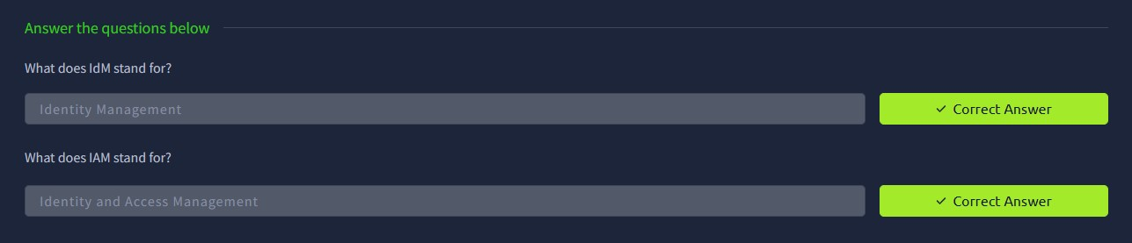

**Task 8:**

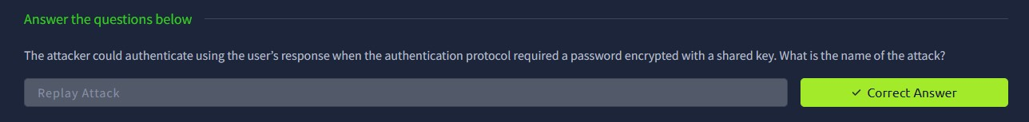

**Task 9:**

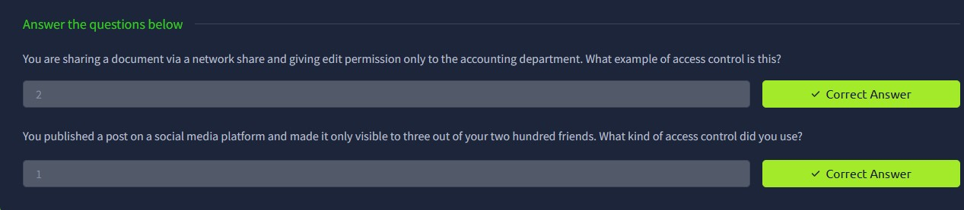

**Task 10:**

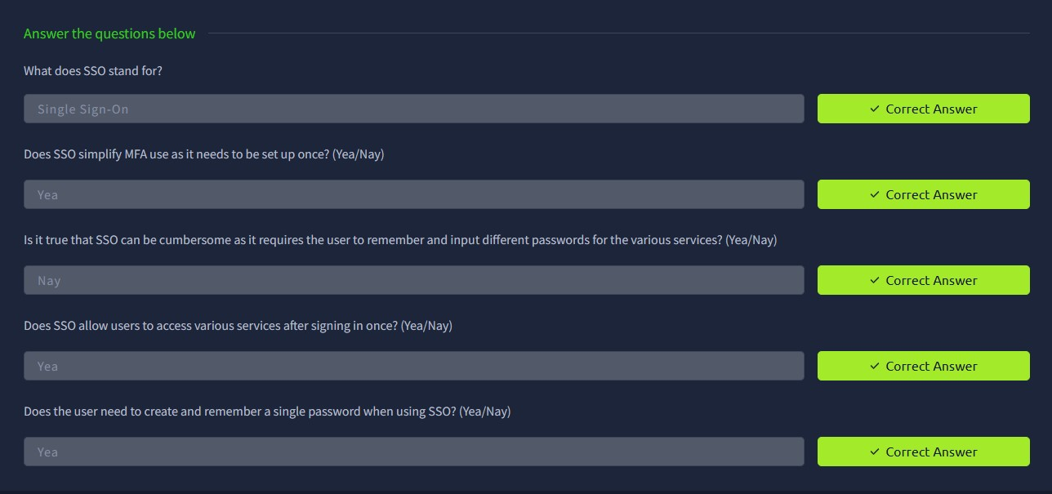

**Task 11:**

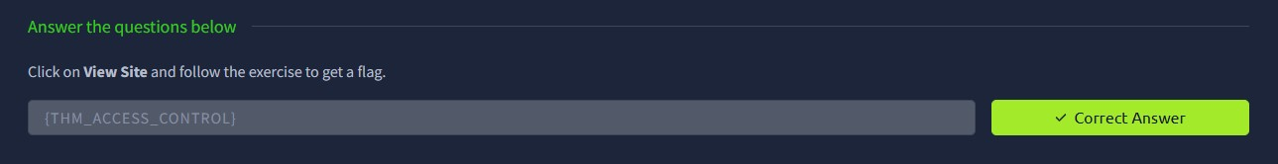

**Task 12:**

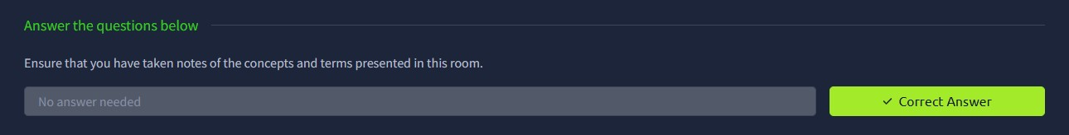

**RESULT:**

Thus the Identity and Access Managementsuccessfully completed in tryhackme platform.